Lab: Script Parameters

In this lab, you will create a new script parameter that contains an integer value representing a value for a number of months. You will then modify an enhancement file to use the script parameter.

Requirements

This lab requires that your first complete the Gosu Enhancement lab.

This lab requires that you use TrainingApp 8.0, Guidewire Studio 8.0, and a supported web browser. To view, edit, and delete various script parameters, log in to TrainingApp as Super User. The login/password for Super User is su/gw. To view, edit, and delete various contacts, log in to TrainingApp as Alice Applegate. The login/password for Alice Applegate is aapplegate/gw. The default URL for TrainingApp is <http://localhost:8880/ab/ContactManager.do>.

1. Create a script parameter

In this exercise, you will first create a script parameter. You will then deploy the script parameter. Finally, you will verify that the script parameter exists in the Administration user interface of TrainingApp.

Tasks

1. Open Guidewire Studio for TrainingApp
2. From Studio, if your server is not already running, start the server using Debug 'Server'.
3. Review the Debug console for errors and verify that the application is running in the Debug console.
4. Create a script parameter
5. Open ScriptParameters.xml
6. Add a script parameter named NumberOfMonthsNextCourtesyContact.
7. Set the parameter value to 6.
8. Deploy your changes
9. Deploy your changes so that the new script parameter is available in both TrainingApp and Guidewire Studio.

Verification

1. Verify the script parameter
2. Log in to TrainingApp as Super User (su/gw).
3. In the tab menu, select Administration.
4. In the Actions panel sidebar, in the side menu, select Utilities, then Script Parameters.
5. Verify that NumberOfMonthsNextCourtesyContact shows in the list view panel.

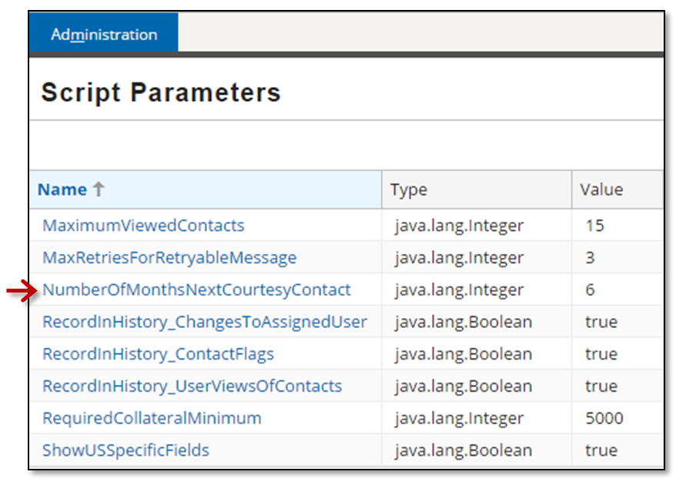

1. Log out of TrainingApp.
2. Modify the enhancement

Previously at Acme Insurance, business rules necessitated that all contacts of the type ABContact should receive a courtesy call once every six months. Now, the rules have changed. Administrator users need to be able to modify the amount of time at a more granular level without requiring the assistance of a configuration developer.

In this exercise, you will modify the NextCourtesyContact() getter property in the ABContact enhancement for analysis to use the NumberOfMonthsNextCourtesyContact script parameter.

Tasks

1. Modify the getter property named NextCourtesyContact()
2. Open the enhancement file for the analysis of contacts in Studio.
3. Modify the getter property named NextCourtesyContact() to return a date that in the future from the Last Courtesy Contact date using the NumberOfMonthsNextCourtesyContact script parameter. If the Last Courtesy Contact date is null then the property must return null.
4. Deploy your changes
5. Deploy your changes to the modified enhancement file.

Verification

1. Verify the modified enhancement and PCF behavior
2. Log in to TrainingApp as Alice Applegate (aapplegate/gw).
3. Search for and open the Albertson's contact.
4. For the contact, navigate to the Analysis page. Click Edit.
5. Set the Last Courtesy Contact field to today's date. Click Update.
6. Verify that the Next Courtesy Contact field shows a date that is 6 months from today's date.
7. Log out of TrainingApp.
8. Update the script parameter value
9. Log in to TrainingApp as Super User (su/gw).
10. In the tab menu, select Administration.
11. In the Actions panel sidebar, in the side menu, select Utilities, then Script Parameters.
12. Click the NumberOfMonthsNextCourtesyContact script parameter in the list view panel.
13. In the popup, click Edit.
14. Change the parameter value from 6 to 9. Click Update.
15. Log out of TrainingApp.
16. Verify the changed script parameter value
17. Log in to TrainingApp as Alice Applegate.
18. Search for and open the Albertson's contact.
19. For the contact, navigate to the Analysis page. Click Edit.
20. Set the Last Courtesy Contact field to today's date. Click Update.
21. Verify that the Next Courtesy Contact field shows a date that is 9 months from today's date.

|  |  |
| --- | --- |
|  | Stop and ask your instructor to review your completed lab. |